LAB PROGRAMS
Day 2- 08/01/2026
Name: K. Guna Shekar Reddy
Register Number: 192424323
Course: CSA0412-Fundamentals of Data Science for Data Analytics

Experiment 6
Program:
import pandas as pd
df = pd.read_csv("supermarket_sales.csv", encoding="latin1")
df.columns = df.columns.str.strip()
df["Subtotal"] = df["Unit price"] * df["Quantity"]
total_cost = df["Subtotal"].sum()
discount_rate = 10
tax_rate = 5
discount_amount = (discount_rate / 100) * total_cost
cost_after_discount = total_cost - discount_amount
tax_amount = (tax_rate / 100) * cost_after_discount
final_cost = cost_after_discount + tax_amount
print("Total cost before discount and tax:", round(total_cost, 2))
print("Discount amount:", round(discount_amount, 2))
print("Tax amount:", round(tax_amount, 2))
print("Final total cost to be paid:", round(final_cost, 2))

Output:
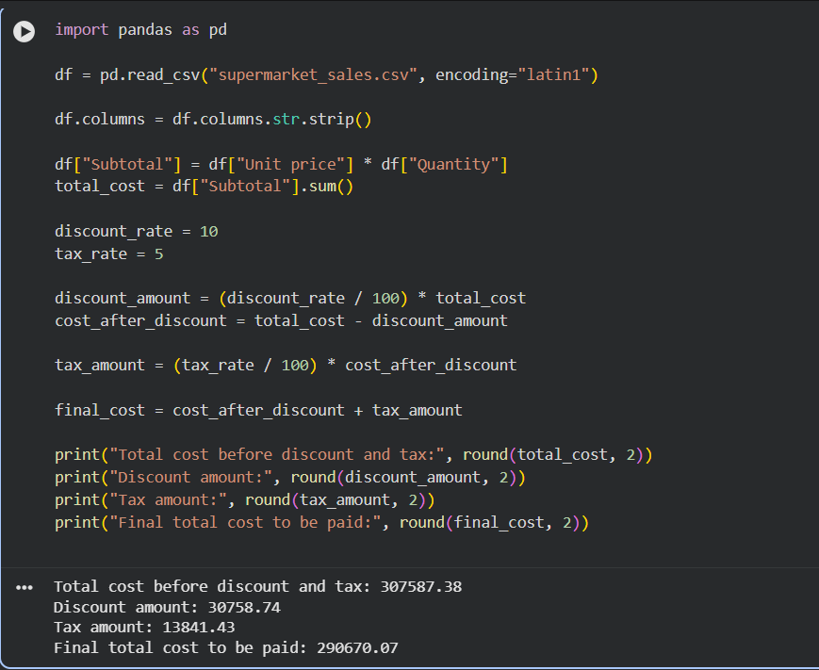

Experiment 7
Program:
import pandas as pd
order_data = pd.read_csv(
"olist_orders_dataset.csv",
encoding="latin1"
)
order_data["order_purchase_timestamp"] = pd.to_datetime(
order_data["order_purchase_timestamp"]
)
orders_per_customer = order_data.groupby("customer_id")["order_id"].count()
order_data["order_quantity"] = 1
average_order_quantity = order_data["order_quantity"].mean()
earliest_order_date = order_data["order_purchase_timestamp"].min()
latest_order_date = order_data["order_purchase_timestamp"].max()
print("Total number of orders by each customer:")
print(orders_per_customer.head())
print("\nAverage order quantity:", average_order_quantity)
print("\nEarliest order date:", earliest_order_date)
print("Latest order date:", latest_order_date)

Output:
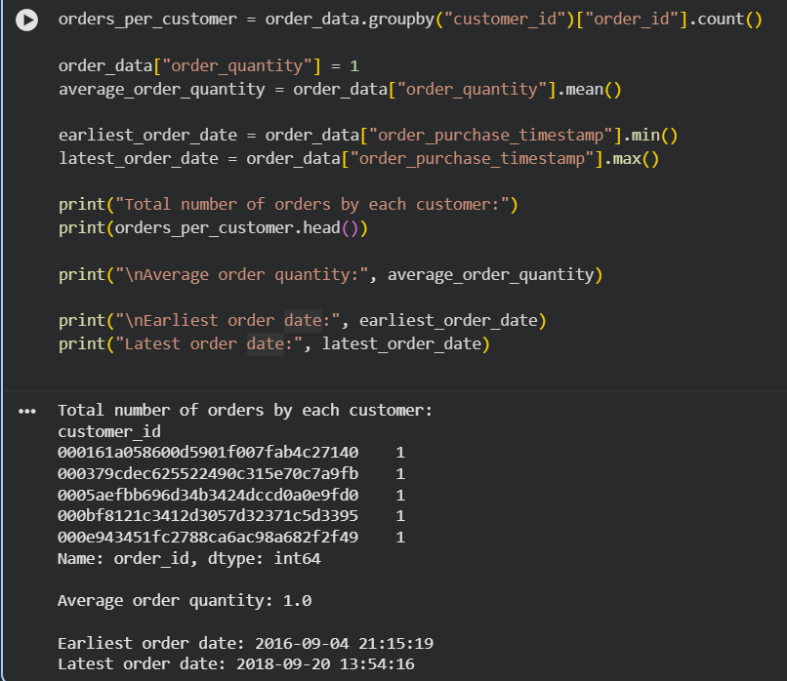

Experiment 8
Program:
import pandas as pd
df = pd.read_csv("data.csv", encoding="latin1", on_bad_lines='skip')
df["InvoiceDate"] = pd.to_datetime(df["InvoiceDate"], errors='coerce')
df.dropna(subset=["InvoiceDate"], inplace=True)
last_month = df["InvoiceDate"].max() - pd.DateOffset(months=1)
last_month_data = df[df["InvoiceDate"] >= last_month]
top_5_products = (
last_month_data
.groupby("Description")["Quantity"]
.sum()
.sort_values(ascending=False)
.head(5)
)
print("Top 5 products sold in the past month:")
print(top_5_products)

Output:
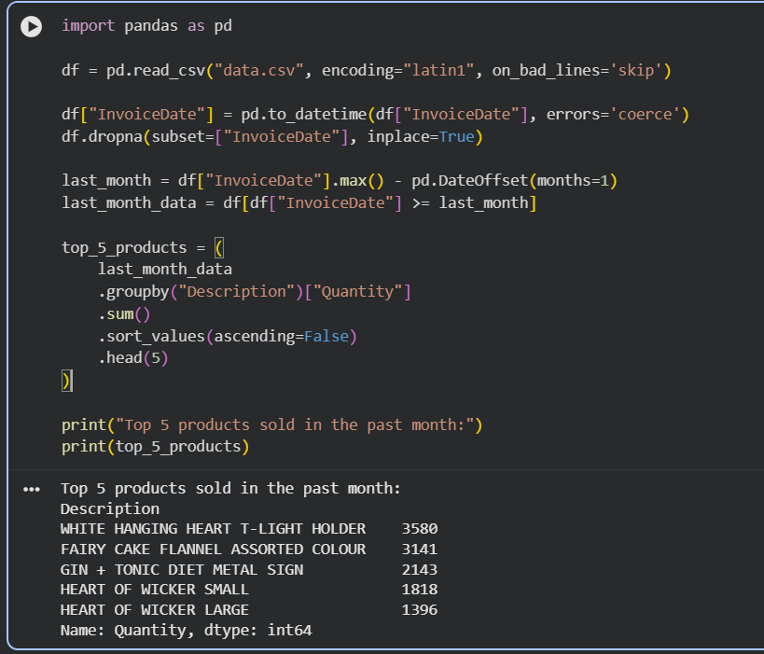

Experiment 9
Program:
import pandas as pd
property_data = pd.read_csv("AmesHousing.csv")
property_data.columns = property_data.columns.str.strip()
if 'Bedroom AbvGr' in property_data.columns:
property_data.rename(columns={'Bedroom AbvGr': 'BedroomAbvGr'}, inplace=True)
if 'Gr Liv Area' in property_data.columns:
property_data.rename(columns={'Gr Liv Area': 'GrLivArea'}, inplace=True)
property_data = property_data[
["Neighborhood", "BedroomAbvGr", "GrLivArea", "SalePrice"]
]
avg_price_by_location = (
property_data.groupby("Neighborhood")["SalePrice"].mean()
)
properties_more_than_4 = property_data[
property_data["BedroomAbvGr"] > 4
].shape[0]
largest_area_property = property_data.loc[
property_data["GrLivArea"].idxmax()
print("Average listing price by location:")
print(avg_price_by_location.head())
print("\nNumber of properties with more than 4 bedrooms:",
properties_more_than_4)
print("\nProperty with the largest area:")
print(largest_area_property)

Output:
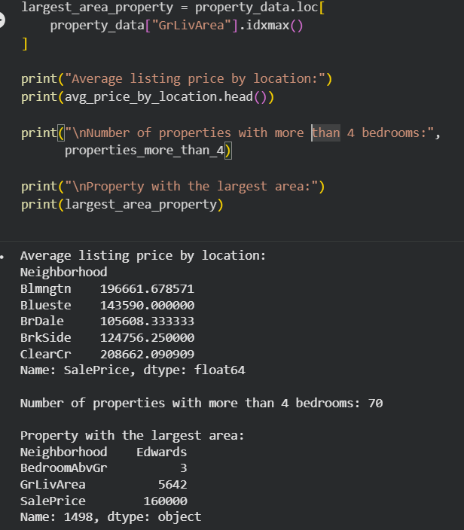

Experiment 10
Program:
import pandas as pd
import matplotlib.pyplot as plt
df = pd.read_csv("sales_data_sample.csv", encoding="latin1")
df["ORDERDATE"] = pd.to_datetime(df["ORDERDATE"])
df["Month"] = df["ORDERDATE"].dt.strftime("%b %Y")
monthly_sales = df.groupby("Month")["SALES"].sum()
plt.figure()
plt.plot(monthly_sales.index, monthly_sales.values, marker='o')
plt.xlabel("Month")
plt.ylabel("Sales")
plt.title("Monthly Sales Line Plot")
plt.xticks(rotation=45)
plt.tight_layout()
plt.show()

plt.figure()
plt.bar(monthly_sales.index, monthly_sales.values)
plt.xlabel("Month")
plt.ylabel("Sales")
plt.title("Monthly Sales Bar Plot")
plt.xticks(rotation=45)
plt.tight_layout()
plt.show()

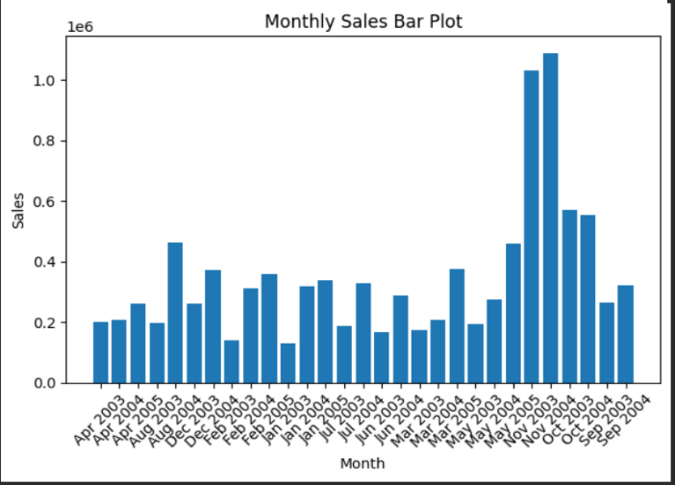
Output:
